**Week 3** Teach Set 1 RWI letters

Squiggle me into a writer

Name writing

**Objective Led Focus- Maths, Addition**

Solve real world mathematical problems with numbers to 5

Know that the last number reached when counting a small set of objects tells you how many there are in total [cardinal number]

Bus stop game

Number of tickets v spaces on the plane- problems

Small world cars-eg 3 cars= how many people can travel?

Travel addition game

Role play going on a journey- how many more can get on the bus? 2 got on and another 2 – how many altogether?

**Week 1-** Teach RWI pictures

Squiggle me into a writer

**Objective Led Focus- EAD Music**

Sing entire songs

Sing pitch of a tone sung by someone else

Sing melodic shapes of familiar songs

Create own songs

Play instruments with increasing control

She’ll be coming round the mountain.

Row, row, row your boat

The pirate song- when I was one

The big ship sails

The wheels on the bus

Down at the station

Five little men in a flying saucer

**Week 2** Teach Set 1 RWI letters

Squiggle me into a writer

Name writing

**Objective Led Focus- UW Forces**

Push or pull? Explore and sort

Magnets

Ball rolling experiment

Dough disco-forces, stretch, squish, pull

Floating boats

Ball skills- rolling and bouncing

Kite/parachute making

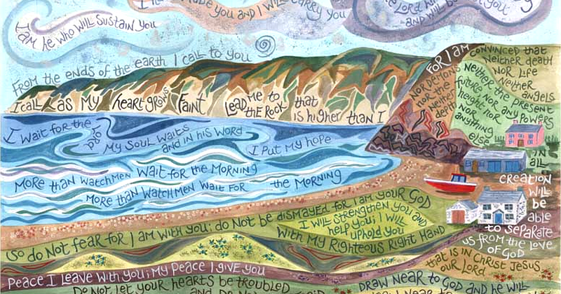

Journeys

**Week 6** Sports Day [ Tues 13th July]

Teach set 1 RWI letters

Squiggle me into a writer

Name writing

**Objective Led Focus- Literacy**

Syllables- clap and count holiday and journey words

Discuss journey to Reception- look at photos of the classroom and make comparisons.

Name parts of a book- cover, pages, back cover, title,

author, illustrator

Daily name writing

Letter writing

Rainbow writing

Roll n write letters

**Week 4** Teach Set 1 RWI letters

Squiggle me into a writer

Name writing

**Objective Led Focus- UW Different countries**

Look at the globe- identify England, do they know the name of any other countries?

Compare China, France, Arctic and India- Mark each country on the map as it is visited. Look at and compare clothing, flag, traditional foods, weather.

Taste traditional foods

Look at significant buildings- Great wall of china, Eiffel tower, Mosques and igloos

Use persona doll.

Discuss which place they would like to go to and why.

**Week 5** Teach set 1 RWI letters

Squiggle me into a writer

Name writing

**Objective Led Focus- Physical Development**

Sports Day practise- learn how to join in with team games.

Use kit bag and balancing equipment to work as a team to build and follow the course.[ going on a journey]

Cutting skills focus.

Squiggle Focus- pencil grip and dominant hand.