**Medium Term Planning Topic Web**

**Personal and Social**

*Explore feelings of scared/worried through ‘It’s the bear’ stories

*Explore Right/wrong through Goldilocks story

*Explore Friendships through ‘ My Friend Bear’

Talk about their bears from home- good listening skills

Family Links sessions

**Communication and Language**

*Develop listening and attention through bear stories

*Extend vocabulary- snout, paws, stitches, hibernate

*Positional Lang- over, under, through

*Listen and respond as children bring in and talk about their bears from home

**Physical Development**

*Dance- acting out ‘We’re Going on a bear hunt’

*Movement to ‘Teddy Bear Teddy bear turn around’

*Exploring movement in the style of different toys

*Use scissors and art and craft tools to create bear collages and pictures

*Dress and undress in boots and coats

* Dough Disco

**Literacy**

*Mark Making development assessment

*Draw/ write about their favourite bear

*Write a list of things to take to the moon [ Whatever Next]

*Sorry card from Goldilocks

*Write picnic food list for baby bear

*Story retell using word or phrases

*Joins in with repeated refrains from stories such as Bear Hunt and Goldilocks

**Numeracy**

*Compare bears- count sets and encourage 1:1 correspondence

*Sort bears by colour/size

*1 more/1 less stories [ Bears in a cave]

*Compare size and begin to use vocabulary- bigger/smaller biggest/smallest

* Order by size [Goldilocks] Bears, spoons, beds

*Use shapes to make bear pictures- discuss

*Use positional language [ Bear Hunt]

**Understanding of the World**

*Compare old and new bears looking at similarities and differences

*Map work linked to ‘We’re going on a bear hunt’- looking at and comparing features of environments

*Learn facts about bears using non-fiction texts

*Study growth of cress head- predict, watch for changes

**Topic- Bears**

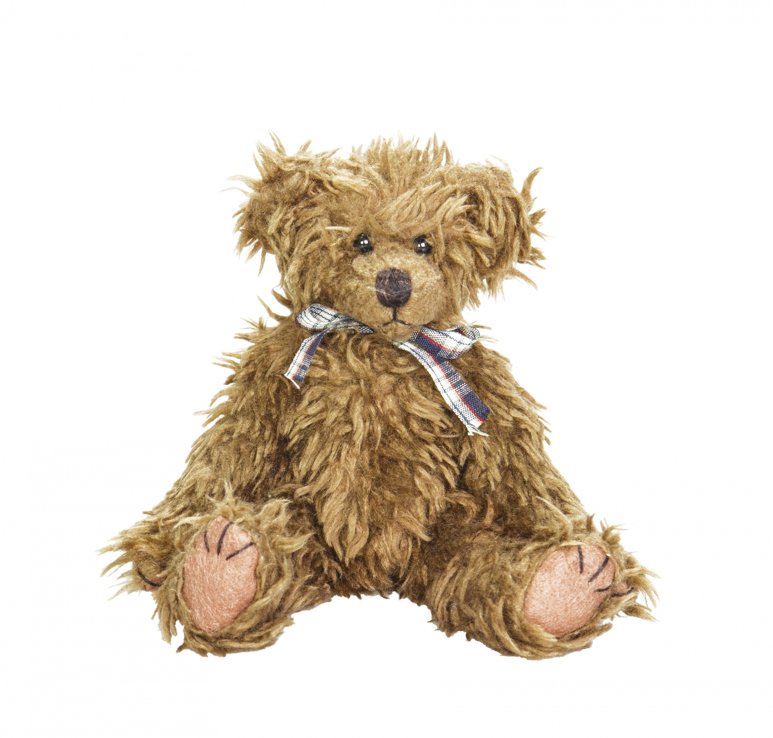

**Expressive Arts and Design**

*Bear collage

*Bear paintings

*Bear observational drawings

*Dance and Music- Bear Hunt, Teddy bear Teddy Bear

*Role Play- Bear Cave and Whatever next

*Outdoors- Going on a bear hunt’ and Teddy Bears picnic