**Week 3**

**Objective Led Focus- Maths- Positional language**

**Snail trail story**

**PVA Snail trails**

**Travelling over, under, around in PE and outdoor environment**

**Create own minibeast trails- record using vocab**

**Obstacle courses outside**

**Hide the minibeast- where is it hiding?**

**Week 1-**

**Objective Led Focus- Literacy**

Non fiction books- looking at books carefully- Introduce vocab- front cover, title, pages, blurb, author, illustrator

Create class fact file using pupil voice- what can you tell me?

Explore plastic minibeasts- sort- look at same and different. Sort legs/ no legs

Read ‘Edward goes exploring’

Teach how to use a magnifying glass and what it is for.

Minibeast hunt outside

Baseline new children

Wellcomm Assessments completed

**Week 2**

**Objective Led Focus- EAD**

**Read Matisse’s magical trail**

**Read Snail trail, a journey through modern art**

**Explore shells**

**Painting spirals**

**Snail collage**

**Spiral shapes from bricks**

**Read ‘How the snail found it’s colours’ – introduce snail view finders**

**Colour mixing**

**Playdough snails- rolling**

**Wax resist spirals**

**Numicon shape snail**

**Week 6**

**Objective Led Focus- Number**

**Spinderella- number problems**

**Counting insect legs**

**Read The Very Busy spider- Teach COEL Linking your thinking**

**Bugs in a jar counting resource**

**Caterpillar fingerprint counting**

**Minibeast hunt tally charts**

**Ladybird spot counting**

**Snail number bonds using numicon**

**Compare numbers of ladybirds cards**

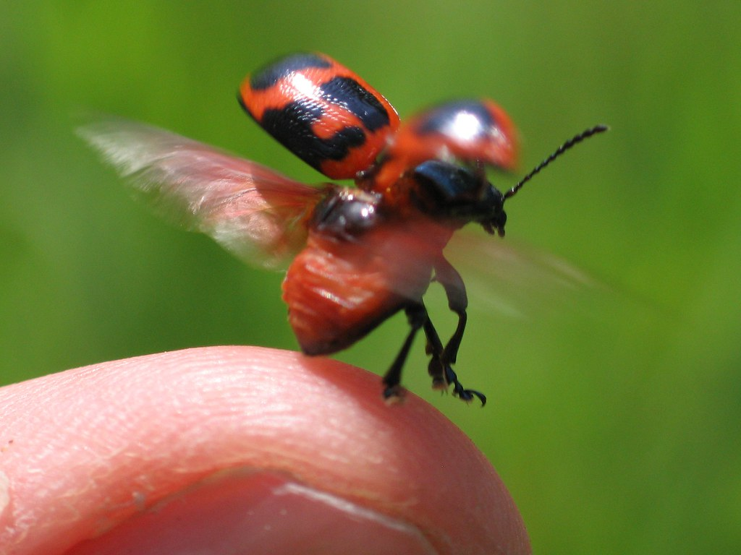

Minibeasts

**Week 4**

**Objective Led Focus- The world**

**Introduce caterpillars and set up**

**Life cycle- order/ sequence**

**Create Bug Hotel in outdoor area**

**Sorting bugs**

**Where do the different minibeasts live? Underground/ on ground/ in air**

**Week 5**

**Objective Led Focus- Literacy/ retelling**

**Read- The Very Hungry caterpillar and retell using different foods**

**Story sequencing**

**Make zig zag caterpillars [ fine motor]**

**Learn rhyme- Ara Bella Millar found a furry caterpillar**

**Learn hungry caterpillar song**