Remote Learning Policy
Westlands First School and Nursery

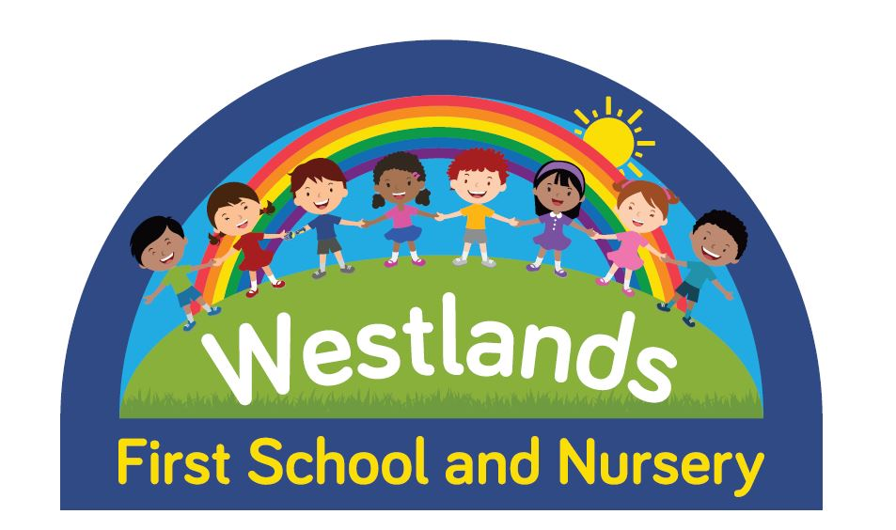

Approved by: |  | Date: 29:09:2020
Last reviewed on: | 07:09:2020
Next review due by: | September 2021

Contents
1. Aims 3
2. Roles and responsibilities 3
3. Who to contact 6
4. Data protection 6
5. Safeguarding 7
6. Monitoring arrangements 7
7. Links with other policies 7

1. Aims
This remote learning policy for staff aims to:
- Ensure consistency in the approach to remote learning for pupils who aren’t in school
- Set out expectations for all members of the school community with regards to remote learning
- Provide appropriate guidelines for data protection

2. Roles and responsibilities
2.1 Teachers
When providing remote learning, during a period of isolation or a local lockdown situation, teachers must be available between 9:00am and 3:30pm.
If they’re unable to work for any reason during this time, for example due to sickness or caring for a dependent, they should report this using the normal absence procedure.
When providing remote learning, teachers are responsible for:
- Setting work:
  - Teachers will be responsible for setting and monitoring work for their own class unless directed otherwise by the home learning team.
  - The work provided will cover English, Maths, Reading and a topic area each day.
  - This work needs to be set by 9am daily
  - Work will be uploaded to Class Dojo or Tapestry. If children do not have access, paper copies will be provided, which can be collected from school.
  - Year group partners will be expected to plan and set the same work. This may be shared, but the teacher of the class will be responsible for setting the work for their own class.
- Providing feedback on work:
  - Pupils will be expected to return work to teachers. Detailed information about this can be found in Appendix 1
  - Feedback to pupils may be through Class Dojo or Tapestry, phone calls or be provided when children return to school.

- Keeping in touch with pupils who aren’t in school and their parents:
  - It is expected that pupils will have at least weekly contact with their teacher. Where pupils are using Class Dojo or Tapestry, this will be the main point of contact. If pupils are not accessing remote learning, a weekly phone call will take place.
  - Teachers are expected to be available to answer emails, Class Dojo or Tapestry queries and responses during the hours of 9am and 3pm.
  - Any safeguarding issues or general concerns should be dealt with following the school’s usual procedures.
  - If pupil’s are failing to complete work, or refusing to work for parents, teachers will have an initial phone conversation with the pupil. Details of this should be recorded on CPOMS. If the situation does not improve, this should be discussed with Rachel Roberts or Seren Freestone.
2.2 Teaching assistants
When assisting with remote learning, teaching assistants must be available during their contracted working hours.
If they’re unable to work for any reason during this time, for example due to sickness or caring for a dependent, they should report this using the normal absence procedure.
When assisting with remote learning, teaching assistants are responsible for:
- Supporting pupils who aren’t in school with learning remotely :
  - TAs who support children 1:1 may provide daily telephone support – this will be discussed and agreed with the parent and SENCO prior to this beginning.
  - TAs will provide support via telephone conversations
Some teaching assistants may be working their hours in school during a lockdown.
2.3 Subject leads
Alongside their teaching responsibilities, subject leads are responsible for:
- Working with teachers teaching their subject remotely to make sure all work set is appropriate and consistent
- Monitoring the remote work set by teachers in their subject , during usual subject monitoring.
- Alerting teachers to resources they can use to teach their subject remotely
- Throughout the lockdown period, this will be reviewed and amendments may be made to clarify subject leader roles and responsibilities to support remote learning over an extended period of time.
2.4 Senior leaders
Alongside any teaching responsibilities, senior leaders are responsible for:
- Co-ordinating the remote learning approach across the school –Sian Lines/Seren Freestone
- Monitoring the effectiveness of remote learning –through regular meetings with teachers and subject leaders, reviewing work set or reaching out for feedback from pupils and parents.
- Monitoring the security of remote learning systems, including data protection and safeguarding considerations – Seren Freestone
2.5 Designated safeguarding lead
The DSL is responsible for:
Please refer to Safeguarding Policy
2.7 Pupils and parents
Staff can expect pupils learning remotely to:
- Be contactable during the school day – although consider they may not always be in front of a device the entire time
- Complete work to the deadline set by teachers
- Seek help if they need it, from teachers or teaching assistants through Class Dojo or Tapestry.
- Alert teachers if they’re not able to complete work
Staff can expect parents with children learning remotely to:
- Make the school aware if their child is sick or otherwise can’t complete work
- Seek help from the school if required.
- Be respectful when making any complaints or concerns known to staff
2.8 Governing board
The governing board is responsible for:
- Monitoring the school’s approach to providing remote learning to ensure education remains as high quality as possible
- Ensuring that staff are certain that remote learning systems are appropriately secure, for both data protection and safeguarding reasons

3. Who to contact
If staff have any questions or concerns about remote learning, they should contact the following individuals:
- Issues in setting work – Seren Freestone
- Issues with behaviour – Rachel Roberts/Seren Freestone
- Issues with IT – log on peritech logbook
- Issues with their own workload or wellbeing – Key Stage leader, Pip Cavilla, Seren Freestone or Rachel Roberts
- Concerns about data protection – Seren Freestone
- Concerns about safeguarding – contact Rachel Roberts (DSL) or Pip Cavilla (Deputy DSL)

4. Data protection
4.1 Accessing personal data
When accessing personal data for remote learning purposes, all staff members will:
- Use the Class Dojo or Tapestry to set work. This work can then be accessed from home or school and can be taken over by another member of staff in the instance of absence or illness.
- Where possible, staff should use work laptops to set work and access pupil work. No pupil work should be saved on personal laptops.
4.3 Keeping devices secure
All staff members will take appropriate steps to ensure their devices remain secure. This includes, but is not limited to:
- Keeping the device password-protected – strong passwords are at least 8 characters, with a combination of upper and lower-case letters, numbers and special characters (e.g. asterisk or currency symbol)
- Ensuring the hard drive is encrypted – this means if the device is lost or stolen, no one can access the files stored on the hard drive by attaching it to a new device
- Making sure the device locks if left inactive for a period of time
- Not sharing the device among family or friends
- Installing antivirus and anti-spyware software
- Keeping operating systems up to date – always install the latest updates

5. Safeguarding
Please refer to Safeguarding Policy

6. Monitoring arrangements
This policy will be reviewed regularly and approved on an annual basis by the governing body.

7. Links with other policies
This policy is linked to our:
- Behaviour policy
- Safeguarding & Child protection policy and coronavirus addendum
- Data protection policy and privacy notices
- Home-school agreement
- ICT and internet acceptable use policy
- Online safety policy

