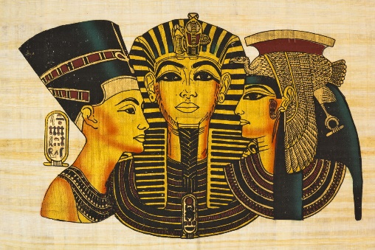
Year 3
Spring 1 Homework
Our new topic is called ‘Tomb Raiders’! Please complete at least three pieces of homework from the grid below. Remember, this is a 6 week term so the homework handed it should reflect the amount of time given. Homework will be due in by Monday 8th February.
Create a wordsearch or crossword about the ancient Egyptians. This can be about one topic if you want. | Make a 3D model of any artefact of your choice. Create a label to go with it as if it were to be displayed in a museum. | Create a tomb or sarcophagus for a mummy. Remember they are decorated with pictures of the person and show off their weath.
Write a secret message in hieroglyphics for a friend to interpret. Take your time and be clear with the pictures! | List 10 things you would NOT see in Ancient Egypt and why. | Research what ancient Egyptian homes were like then show in pictures, words or a model what you have learnt.
Research a famous Pharaoh or Queen of Egypt. You can choose how to present your information (e.g. a poster or diary entries by pretending you are them). | Create a fact file about Ancient Egypt. Think about the River Nile, the pyramids, the gods, food and drink and anything else that you find interesting. | Using any materials of your choice (fabric, clay, paint, paper), create an outfit that could have been worn in Egyptian times.

Don’t forget to continue practising your times tables as we will be continuing with weekly challenges!

