**Personal Social and Emotional Development**

Through this topic and ‘Family Links’ we will help support the children’s emotional wellbeing and support them back into the daily routine at school.

**Expressive Art and Design (including Music)**

We will explore applying paint and using colour to express emotion. We will be learning about pulse and how to move our body in time to the beat.

**The Colour Monster**

***and***

**The Worrysaurus**

**Through the books The Colour Monster by Anna Llenas and the Worryasaurus by Rachel Bright, we aim to support the children’s wellbeing and help them understand the emotions and worries that they may have developed over the past few months.**



**Understanding the World (including Geography/ History/ Science/ RE)** We will encourage the children to show an interest in people and communities and join in with discussions. We will learn about different materials and explore timelines in living memory. We will reinforce the importance of good hygiene and handwashing.

**Mathematics**

We will focus on numbers to 10.

We will count sets accurately within 10, represent numbers to 10 and explore number bonds to 10, using a whole-part model.

We will sort and count different coloured objects ensuring we recite the numbers in the correct order and count accurately.

**Communication and Language**

We will focus on giving the children the language they need to discuss how they feel and support them to express their feelings to others. We will encourage active listening skills.

**Literacy/ English**

We will read key texts which explore emotions. Through fictional stories we will encourage the children to ascribe meaning to the illustrations and talk about the characters and plot. When writing our responses to the texts, we will develop our grammar and punctuation skills. We will begin to write captions and sentences with increasing independence.

We will further develop our phonics skills through structured RWI group sessions.

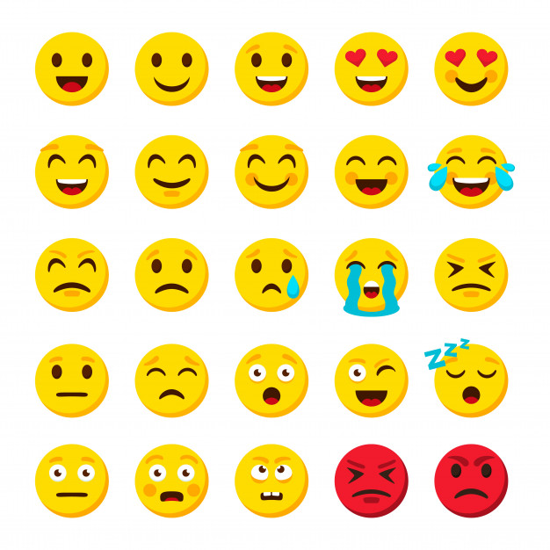

**Physical Development**

We will move in a variety of ways to express different emotions.

We will develop our spatial awareness and introduce weekly yoga sessions.

We will develop our fine motor and handwriting skills and begin to learn cursive letter formation.