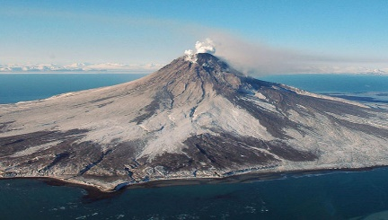Year 3

Autumn 2 Homework

Our new topic is called **‘Violent Volcanoes’**! Please complete at least **three** pieces of homework from the grid below. Remember, this is a 7 week term so the homework handed it should reflect the amount of time given. Homework will be due in by **Monday 14th December.**

|  |  |  |
| --- | --- | --- |
| Research a famous volcano and present your findings (e.g. a report, a poster, a newspaper report etc.) | Make a 3D model volcano – be as creative as you want! | Conduct your own ‘volcanic’ science investigation using bicarbonate of soda and vinegar and choose how to present your findings e.g. photographs, in a table, a written explanation. |
| Make a volcano safety poster explaining what to do to keep safe should you live near one! | Write an acrostic poem using the letters from the word ‘VOLCANO’ | Write an A-Z list of adjectives (or other words) you could use to describe a volcano |
| Write 10 questions you would like to ask someone who has witnessed a volcanic eruption. | Create a board game inspired by the volcanoes topic. | Research and present findings in your own words about different types of volcanoes |

Don’t forget to continue practising your times tables as we will be starting weekly challenges!