English:

**In English, we will be reading the book When the Giant Stirred by Celia Godkin. We will begin by exploring how the words in the text help to create images as well as the actual words before making predictions about what we think the story will be about.**

**After that, we will explore how to use the story to create our own descriptive sentences creating expanded noun phrases and prepositional phrases in readiness for writing our own setting description paragraphs.**

Science skills:

**We will be learning how to set up simple practical enquiries and making careful observations. We will be considering fair testing and then gathering and recording results in order to draw simple conclusions on what we found out. We will also be challenging our scientific thinking to make suggestions on how to improve our lines of enquiry.**

Maths:

**As mathematicians, we will continue to add and subtract, building up our skills of mentally calculating adding/subtracting ones, tens and hundreds before moving onto using the formal method of column subtraction. We will also be looking at multiplication and division for the 3, 4 and 8 times tables.**

Violent Volcanoes

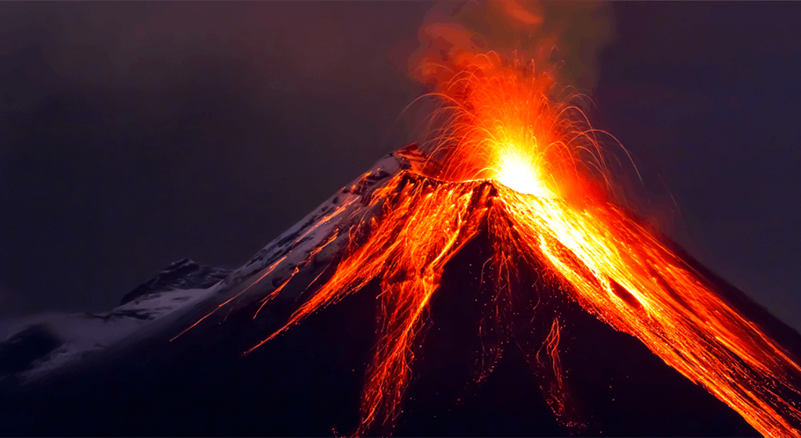

Computing:

**As computer scientists, we be following the e-safety programme, looking at how to stay safe when online. We will talk about how to use technology safely, respectfully and responsibly and how to recognise acceptable/unacceptable behaviour. We will also look at ways on how to report concerns and who we should talk to when we see something we don’t like.**

Art:

**As artists, we will be revising colour mixing and looking at how to create tints and shade. We will then explore how to use colour to create effects and moods in painting.**

Geography:

**As geographers, we be looking at volcanoes and their location around the world. We will locate and name the continents on a world map as well as the Equator and the North and South Hemisphere. We will be using maps, atlases and Google earth to help us do this.**

French:

**As modern foreign language learners, we will be learning to count to 10 and use our knowledge of this to say how many and how old I am. We will them move on to class instructions.**

RE:

**As religious education experts, we will be looking at the Islamic faith. We will look at who and where the faith was founded, what key beliefs are held by Muslims, identify the key features of their place of worship as well as name and explain key Muslim festivals.**

PE:

**This half term, Year 3 will be doing yoga with Mrs Whitehead.**

PSHE:

**In PSHE, we will be following the e-safety programme.**