**Maths:**

**As mathematicians, we will be recapping place value of 2-digit numbers and ordering and comparing them. We will also be recalling addition and subtraction facts and then moving onto addition and subtraction of two 2-digit numbers using what we have learnt to support our calculations.**

**English:**

**As readers, we will be retrieving information from fiction and non-fiction texts and also making predictions using clues in the texts that we read.**

**As writers, we will be exploring how to engage the reader and giving specific information in order to write effective explanation texts.**

**Science:**

**As scientists, we will be investigating rocks and soils.**

**We will look at the definition of a rock and where they are found. We will begin to sort rocks by their properties then move onto how rocks are made, sorting rocks by their scientific names.**

**We will explore the concept of fossils and how they are made.**

**Finally, we will look at soil, how soil is made and what a soil profile is and why it is important.**

**Science skills:**

**We will be performing simple investigations and discussing how the results of these help us to understand the past.**

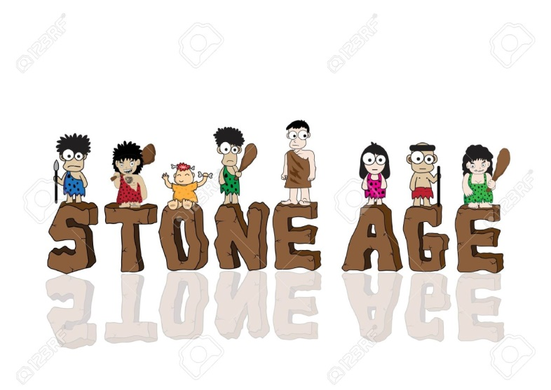

**Digging up the Past**

**DT:**

**In design and technology sessions, we will be designing and constructing simple Stone Age tools using natural material. We will also be making a Stone Age seasonal stewed fruit and comparing it to a modern day alternative. We will also be designing and constructing Iron Age carts.**

**French:**

**As modern foreign language learners, we will be learning how to greet one another and how to say what my name is and how I am feeling.**

**History:**

**As historians will be delving into the Stone Age. We will explore how Stone Age people lived and how their lives were different to ours. We will look at a range of themes including tools, hunting and cave art.**

**RE:**

**As religious education experts, we will be exploring who founded Hinduism and where it all began. We will also look at the main beliefs of Hinduism and explain which places and symbols are special to Hindus.**

**PSHE:**

**We will continue the Family Links programme.**

**PE:**

**Athletics – running, jumping and throwing**