**Science:**

As scientists we will be investigating everyday materials. We will distinguish between an object and the material from which it is made.

**Science skills:**

We will be making a prediction before investigating a range of materials. We will need to design a fair test and then take part in the investigation. We will use the results in order to draw conclusions and make suggestions on how to improve our investigation.

**Writing:**

As writers, we will be meeting a naughty toy bus and learning about his journey through the day. During our journey with the naughty bus, we are going to make predictions about where he may go, writing instructions, retell the story and create our own version of the story using different toys and locations.

**Maths:**

As mathematicians we will be demonstrating our knowledge of Place value,

Sequencing and recognising numbers, recognising 1 more 1 less. Using our addition skills we will recognise the number bonds to 10/20 and use our measuring skills and vocabulary to identify the height and weight of objects.

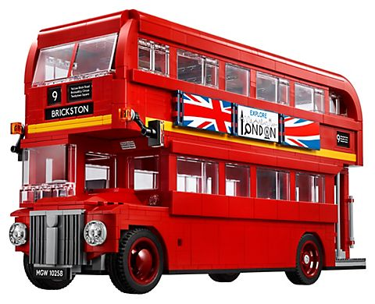

**Ding ding**

**Computing:**   
We will find out how information technology is used in the home and school environment.

We will also be using a group login to access the computer systems whilst using our keyboard skills. We will also be learning how to keep ourselves safe online.

**PSHE:**   
As democratic members of Year 1, we will be contributing and deciding on rules for our classroom and learning how to work as part of an effective team. We will be working hard to improve our self organisational skills and understanding that we need to show consideration and thoughtfulness towards others when making our choices.

**DT:**We will design and use our measuring, cutting and joining skills to build a toy bus out of cardboard and plastic.

**Music:**

Using expression in our voices we will be working and performing as a group to sing and chant a selection of vehicle songs and rhymes keeping in time with the rhythm and beat.

Learn to follow a conductor

**Geography:**

As geographers, we will be using maps and atlases to locate the United Kingdom and its countries before recognising and understanding the difference between physical and human features.

**RE:**

In our RE lessons, we will be recognising who is a Christian and what they believe. We will begin to know and respect the religion of Christianity and identify symbols and images that are important to the Christian community.

**History:**

As historians, we will be investigating toys from the past and compare them to toys we use now.