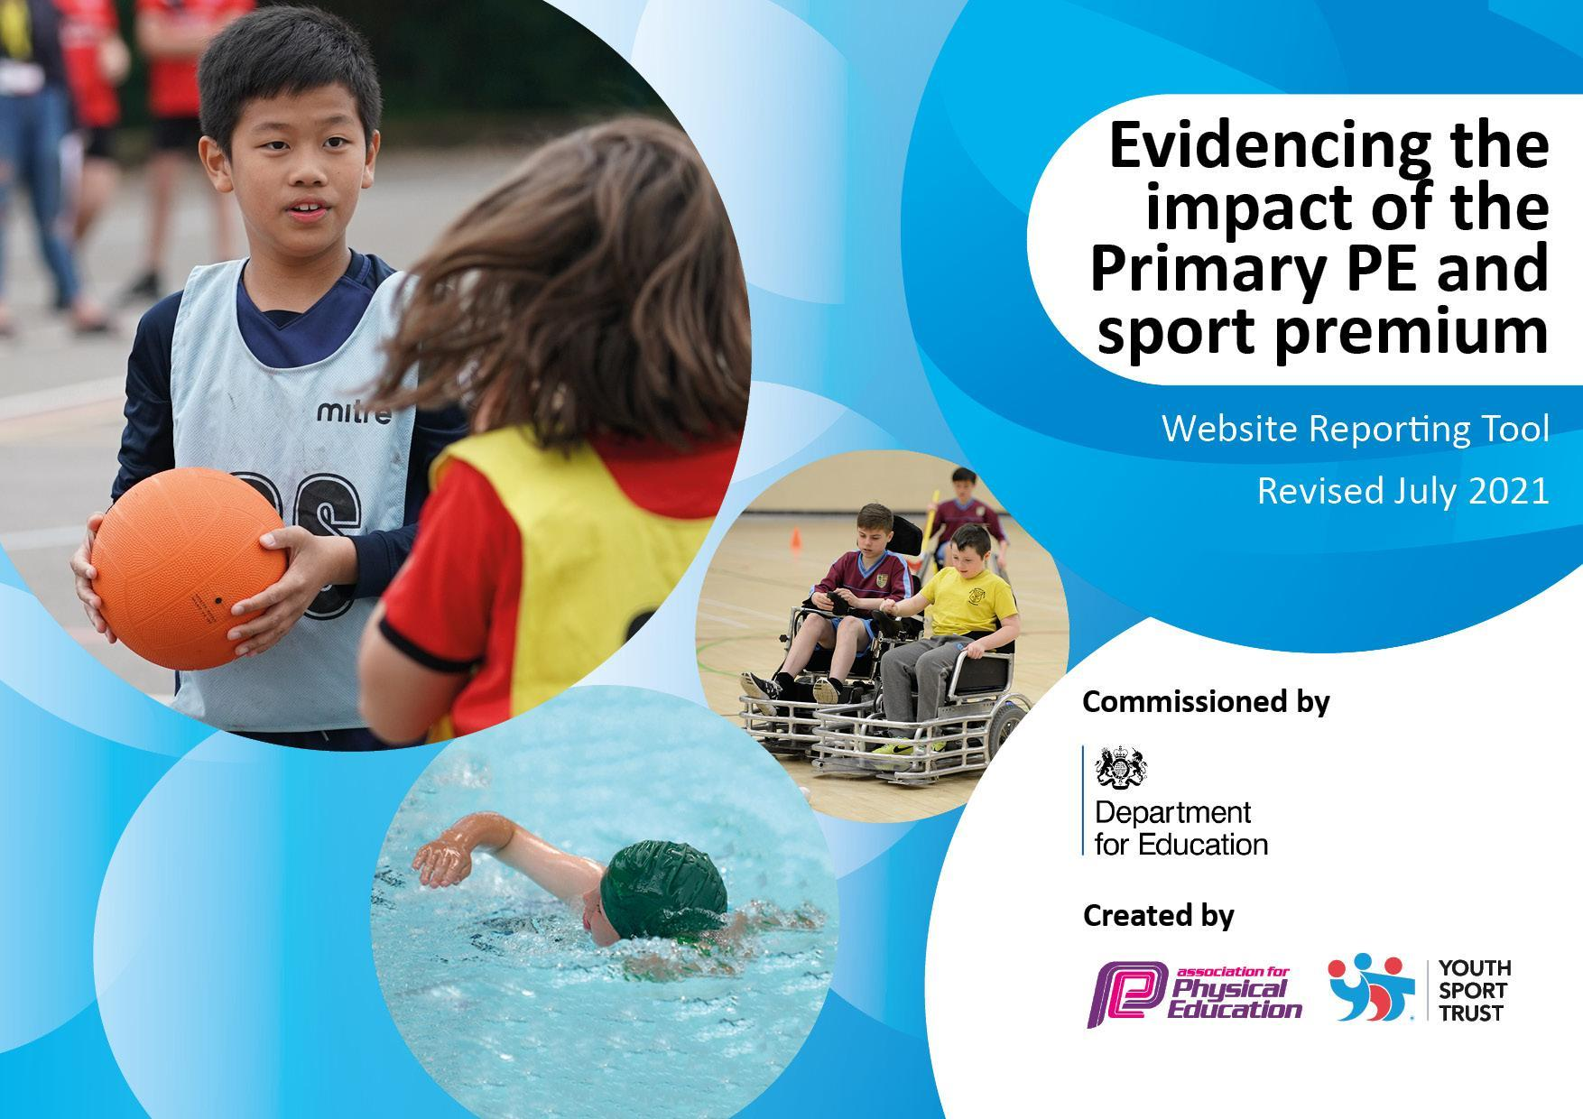
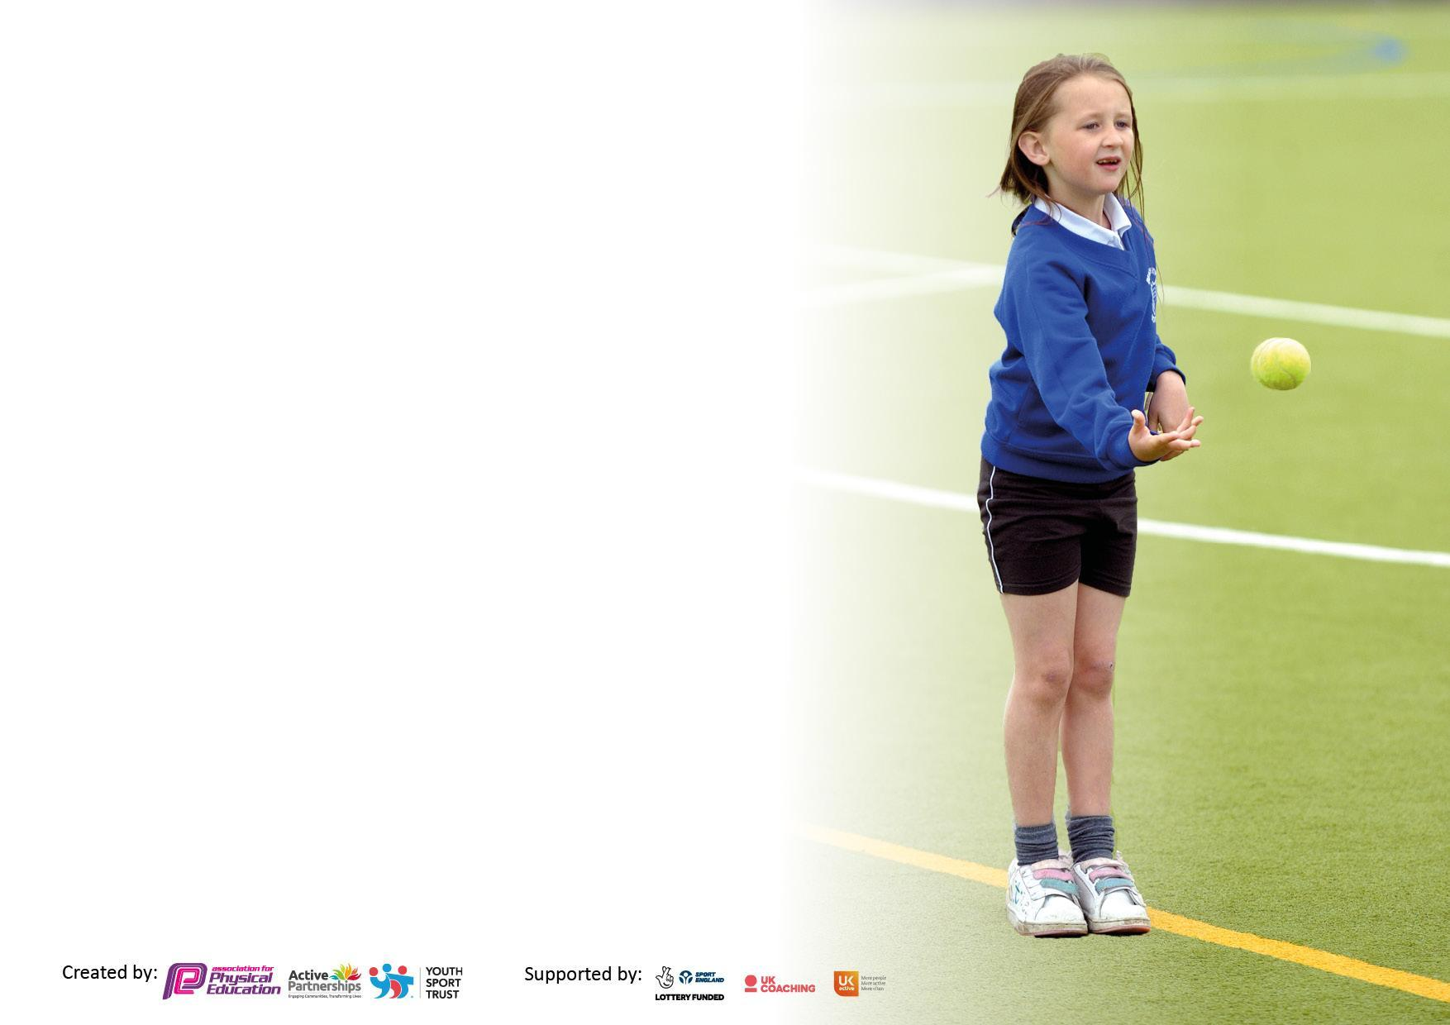

It is important that your grant is used effectively and based on school need. The Education Inspection Framework makes clear there will be a focus on ‘whether leaders and those responsible for governors all understand their respective roles and perform these in a way that enhances the effectiveness of the school’.

Under the Quality of Education Ofsted inspectors consider:
Intent - Curriculum design, coverage and appropriateness
Implementation - Curriculum delivery, Teaching (pedagogy) and Assessment
Impact - Attainment and progress

To assist schools with common transferable language this template has been developed to utilise the same three headings which should make your plans easily transferable between working documents.

Schools must use the funding to make additional and sustainable improvements to the quality of Physical Education, School Sport and Physical Activity (PESSPA) they offer. This means that you should use the Primary PE and sport premium to:

- Develop or add to the PESSPA activities that your school already offer
- Build capacity and capability within the school to ensure that improvements made now will benefit pupils joining the school in future years
- The Primary PE and sport premium should not be used to fund capital spend projects; the school’s budget should fund these.

Pleasevisitgov.ukfortherevisedDfEguidanceincludingthe5keyindicatorsacrosswhichschoolsshoulddemonstrate animprovement.Thisdocumentwillhelpyoutoreviewyourprovisionandtoreportyourspend.DfEencouragesschools to use this template as an effective way of meeting the reporting requirements of the Primary PE and sport premium.

We recommend you start by reflecting on the impact of current provision and reviewing the previous spend.

Schools are required to publish details of how they spend this funding, including any under-spend from 2019/2020, as well as on the impact it has on pupils’ PE and sport participation and attainment. All funding must be spent by 31st July 2022.

We recommend regularly updating the table and publishing it on your website throughout the year. This evidences your ongoing self-evaluation of how you are using the funding to secure maximum, sustainable impact. Final copy must be posted on your website by the end of the academic year and no later than the 31st July 2021. To see an example of how to complete the table please click HERE.


Created by: Supported by:

Details with regard to funding
Please complete the table below.

Total amount carried over from 2019/20 | £4901.54
Total amount allocated for 2020/21 | £17670.00
How much (if any) do you intend to carry over from this total fund into 2021/22? | £8440.98
Total amount allocated for 2021/22 | Approx £17500.00
Total amount of funding for 2021/22. To be spent and reported on by 31st July 2022. | £25940.98

Swimming Data
Please report on your Swimming Data below.

Meeting national curriculum requirements for swimming and water safety.

N.B. Complete this section to your best ability. For example you might have practised safe self-rescue techniques on dry land which you can then transfer to the pool when school swimming restarts.
Due to exceptional circumstances priority should be given to ensuring that pupils can perform safe self rescue even if they do not fully meet the first two requirements of the NC programme of study
What percentage of your current Year 4 cohort swim competently, confidently and proficiently over a distance of at least 25 metres?  N.B. Even though your pupils may swim in another year please report on their attainment on leaving primary school at the end of the summer term 2022.  Please see note above | 50%
What percentage of your current Year 4 cohort use a range of strokes effectively [for example, front crawl, backstroke and breaststroke]?  Please see note above | 50%
What percentage of your current Year 6 cohort perform safe self-rescue in different water-based situations? | % NA
Schools can choose to use the Primary PE and sport premium to provide additional provision for swimming but this must be for activity over and above the national curriculum requirements. Have you used it in this way? | Yes/No

Action Plan and Budget Tracking
Capture your intended annual spend against the 5 key indicators. Clarify the success criteria and evidence of impact that you intend to measure to evaluate for pupils today and for the future.

Academic Year: 2020/21 | Total fund allocated: | Date Updated:
Key indicator 1: The engagement of all pupils in regular physical activity – Chief Medical Officers guidelines recommend that primary school pupils undertake at least 30 minutes of physical activity a day in school |  |  |  | Percentage of total allocation:
 |  |  |  | %
Intent | Implementation |  | Impact
Your school focus should be clear what you want the pupils to know and be able to do and about  what they need to learn and to  consolidate through practice: | Make sure your actions to achieve are linked to your intentions: | Funding allocated: | Evidence of impact: what do pupils now know and what can they now do? What has changed?: | Sustainability and suggested next steps:
- To continue to implement ‘daily mile’ for each year group as part of a school’s target  - To encourage active learning via more physical lessons  - To encourage active play during break times and lunchtimes by implementing and using effectively new outdoor equipment  - To raise the attainment of swimming in Y4 to meet the requirements of the national curriculum before the end of KS2  - Children to keep active during play and dinner times and engage in sensible games; help children regulate their behaviour when being active  (linked to Regulation Stations - whole school approach)  - Children to keep keep active during play and lunch times by raising the profile of ‘friendly football game’  - Y1 children to have their classroom learning extended into the outdoor space to provide for the continuous provision and to enhance further their physical development and outdoor focused play | - Measure the distance around the playground daily using class step pedometers (focus on Y3/4)  - Each class/year group to have a daily/weekly target to achieve  - As part of joining The Wyre Forest School Partnership, classes are to take part in live physical lessons on half termly basis  - New outdoor equipment bought; introduce and implement in Spring 2 onwards  - School Council to discuss the role of Playleaders  - Extra swimming sessions secured (Autumn and Spring terms); majority of the children to swim unaided at least 10m on front and back  - invest/design both playgrounds with games markings/signs to engage children in sensible free play  - invest in goal posts and football equipment; set up the grass area as the designated football area  - improve the outdoor area of Y1 classes and plan for the continuous provision by investing in appropriate outdoor equipment in line with the PE National Curriculum objectives | £2355  (part of Wyre Forest School partnership contribution)  £2200  £430  £5200  £730  £1300  £1300 | Daily mile was dropped in Summer term due to a new timetable  Classes continued to take part in active lessons throughout the year and thoroughly enjoyed it.  It has been a very successful initiative; Play Leaders have carried out their roles responsibly and have enjoyed their experience. A wide selection of play equipment has been used well and a number of lunchtime games have been implemented effectively. All children have enjoyed and benefited from the experience.  Quote approved; delivery/installation planned for Sept. 2022; markings to be shared with the children at school.  The area to be set up in Sept. 2022.  The equipment to be used from Sept. 2022. | After a recent review -  a new playground marking is to be installed on the playground which will help achieving the ‘daily mile’ more purposefully and accurately (completion date Sept 2022)  To continue with the Playleaders; train and deploy new Playleaders from current Y3.
Key indicator 2: The profile of PESSPA being raised across the school as a tool for whole school improvement |  |  |  | Percentage of total allocation:
 |  |  |  | %
Intent | Implementation |  | Impact
Your school focus should be clear what you want the pupils to know and be able to do and about  what they need to learn and to  consolidate through practice: | Make sure your actions to achieve are linked to your intentions: | Funding allocated: | Evidence of impact: what do pupils now know and what can they now do? What has changed?: | Sustainability and suggested next steps:
- To continue to use professional role models (coaches: tennis, rugby, yoga, swimming) in school to deliver high quality PE lessons and inspire children to take up a wider range of sports  - To actively encourage pupils to take on leadership roles that support the delivery of sport and physical activity (Play leaders)  - To train and deploy Play Leaders across the year groups to encourage and model physical activity to others  - To raise pupils’ awareness of how to keep themselves and others safe on the playground and in their play  - Teachers and children to have access to a wide range of relevant PE equipment in line with the new PE scheme  - To raise pupils’ awareness of the links between healthy eating and regular exercise to ensure a healthy lifestyle | - Plan for delivered/taught sessions on a weekly/termly basis  - Teaches to observe, shadow and support deployed coaches in order to improve their PE teaching skills/techniques, knowledge and raise confidence level  - To liaise with the School Council and agree on the role of Play leaders and purpose of the Friendship Stop  - Use SSP initiative – bespoke support provided for teachers on termly basis – focus Dance/Gymnastics  - To liaise with SSP (Carolyn) to arrange for her to come and train Playleaders  - To find out what the problem is on the playground (playground safety audit)  - To audit and order new relevant PE equipment to be used next academic year in PE lessons  - to audit children’s kitchen equipment and order more appropriate kitchen equipment and utensils, in preparation for next academic year's plan of refurbishing the children’s kitchen. This will be the beginning of our whole school healthy lifestyle incentive. Staff will be asked to plan a termly unit of work to prepare and make healthy snacks, as part of our wider healthy lifestyle curriculum. | £5200  (Autumn term)  £2355 (part of Wyre Forest School annual fee)  £1500  £3300 | Children have enjoyed well planned lessons and learnt new skills. Coaches’ expertise in their own areas ensured high quality coaching. | To continue working alongside professional coaches and gain more knowledge and expertise of the delivery of different units of PE.  To train and deploy more Play Leaders from current Y3.

Key indicator 3: Increased confidence, knowledge and skills of all staff in teaching PE and sport |  |  |  | Percentage of total allocation:
 |  |  |  | %
Intent | Implementation |  | Impact
Your school focus should be clear | Make sure your actions to | Funding | Evidence of impact: what do | Sustainability and suggested
what you want the pupils to know | achieve are linked to your | allocated: | pupils now know and what | next steps:
and be able to do and about | intentions: |  | can they now do? What has
what they need to learn and to |  |  | changed?
consolidate through practice:
- Children to have an opportunity to develop an enjoyable Dance sequences  - Raise the profile of teaching Dance across school after the Covid pandemic  - Provide staff with professional development opportunities, appropriate training and resources to help them teach PE and sport more effectively and confidently (Use SSP bespoke initiative, focus Dance and Gymnastics)  - Continue to hire qualified sports coaches to work alongside teachers to enhance or extend current opportunities offered to pupils  - Subscribe to a new PE scheme (Get Set 4 PE) to enable teachers to follow and deliver progressive, well planned PE lessons for each curriculum unit, focusing on developing children’s skills, confidence and enthusiasm for playing sports | - Source a Dance Specialist to come and deliver dance sessions with different year groups to develop progression in sequences of dance in Y4  - Plan for Dance sequences to be delivered at least once a year  - PE coordinator to attend PE conferences on a regular basis  - Use SSP Bespoke initiative sessions to target staff in order to develop weak areas in PE knowledge and teaching  - Teachers should learn from coaches the necessary skills to be able to teach these new sports and physical activities effectively | £500  £1375 + VAT  (per annum) | Children in Y4 have benefitted from well planned and enjoyable dance sessions linked to the topic they have been learning in class (WW2). They have developed a sequence of new movements and worked together on learning 1930’s swinging dance. They improved their overall confidence in solo and group performance, which resulted in a whole year dance performance for the end of year production.  Furthermore, the sessions improved teachers’ confidence on how to develop and deliver a dance sequence based on a topic taught in class.  Sports coaches – very successful; children enjoy sessions and are introduced to a wide variety of sports; coaches are very professional and run well planned, enjoyable sessions.  Children have developed many new skills in each unit taught as well as developed a more competitive spirit after taking part in games.  Teachers (after shadowing coaches and actively supporting them in lessons) have improved their confidence on how to deliver specific units in PE sessions more effectively.  No evidence yet as the scheme will be implemented in September 2022. | All year groups to have a professional Dance Coach for one unit of work in the next academic year in order to raise the profile of dance and enable children to experience high quality dance provision.
Key indicator 4: Broader experience of a range of sports and activities offered to all pupils |  |  |  | Percentage of total allocation:
Intent | Implementation |  | Impact
Your school focus should be clear | Make sure your actions to | Funding | Evidence of impact: what do | Sustainability and suggested
what you want the pupils to know | achieve are linked to your | allocated: | pupils now know and what | next steps:
and be able to do and about | intentions: |  | can they now do? What has
what they need to learn and to |  |  | changed?:
consolidate through practice:
- Pupils to experience a broader and more quality coverage of different sport disciplines across the year groups throughout the academic year  - Pupils in Y3/4 to have an opportunity to develop and practice tennis on a longer-term basis  - More children take up tennis outside school hours.  - Children to enjoy taking part in sports competitions and develop an element of competitiveness  - More children to swim unaided by the end of Y4 and develop ‘love’ for swimming as one way of keeping healthy  - Children to be encouraged to take up swimming outside school as one way of keeping healthy  - Children to engage in fun activities focusing on their fine motor skills  Planned for next academic year (Sept. 2022 - 2023)  - Develop the ‘Orienteering’ unit of KS2 curriculum in order to promote children’s stamina, independence, spatial reasoning abilities as well as cooperation skills  - to improve teachers’ confidence in dance teaching and planning across all year groups | - Continue to hire specialist coaches (tennis, rugby, yoga, swimming)  - Extend the coverage of tennis in KS2 to allow for the development and consolidation of specific tennis skills  - As a result of school’s partnership with the local Droitwich Tennis Club, Y4 pupils were offered half-price tennis sessions  - Partner with other schools and engage in termly sports festivals as part of Droitwich Cluster schools  - Provide more time/number of swimming sessions for children in Y4 in order to increase the proportion of children who can swim 10m/25m  - Circus afternoon (Summer term)  - to deploy an orienteering coach to deliver well-planned session in Y3 and Y4 in Summer term  - dance teacher to deliver an unit of dance in each year group (x 1 half term) | as above  (coaches)  £2355  (part of Wyre Forest School partnership contribution)  £1188  (extra term of swimming)  £1000 | A wider range of sport coaches has enabled classes throughout the whole school to access a much broader PE curriculum.  All sessions have been very well planned and delivered, addressing children’s needs.  Children enjoyed the sessions, learnt new skills and some pursued their new sport interests outside of school.  No children able to swim unaided at the start of term  17.02.22  50% of children in Y4 (12) able to swim 10m unaided after a term and half of swimming lessons.  10 children were able to swim 25m. | To continue working alongside professional coaches.

Key indicator 5: Increased participation in competitive sport |  |  |  | Percentage of total allocation:
 |  |  |  | %
Intent | Implementation |  | Impact
Your school focus should be clear | Make sure your actions to | Funding | Evidence of impact: what do | Sustainability and suggested
what you want the pupils to know | achieve are linked to your | allocated: | pupils now know and what | next steps:
and be able to do and about | intentions: |  | can they now do? What has
what they need to learn and to |  |  | changed?:
consolidate through practice:
- To increase and actively encourage pupils’ participation in the School Games and take part in competitions and tournaments, both inter-house and with local schools in order to keep fit and healthy and represent their school in the local area  - Pupils to develop ‘the competitive spirit’ by taking part in PE Festivals with local primary schools (termly)  - Pupils to develop the values of determination, honesty, passion, respect and self-belief by participating in competitive games | - To encourage classes/year groups to compete against each other (Summer term – two Y4 classes/Y2 classes) – intra-school competitions  - Each year group to attend a ‘themed’ PE festival where children can practice their skills and take part in competitions with other schools in a fun and friendly way (organiser - Carolyn Goddard, held at Westacre Middle School) – inter-school competitions  - Engage with other schools in the pyramid cluster and take part in inter-school competitive games (organiser – Paul Chester) | £2355  (part of Wyre Forest School partnership contribution) | 16.02.22  Not successful so far due to covid restrictions, no school games with local schools have taken place so far.  Very successful in each year group; the festivals were well organised and enabled children to apply their skills at school in another, competitive context.  Children had an opportunity to challenge themselves and to have ‘a taste’ for what it means to take part in a competition. | A new person (Tracy Freer) in charge of School Games from Sept. 2022; sign up as a school.  To continue taking part in festivals (each year group if possible).

Signed off by
Head Teacher: | Rachel Roberts
Date: | 29:08:22
Subject Leader: | Justyna Larke
Date: | 18.07.22
Governor:
Date:

