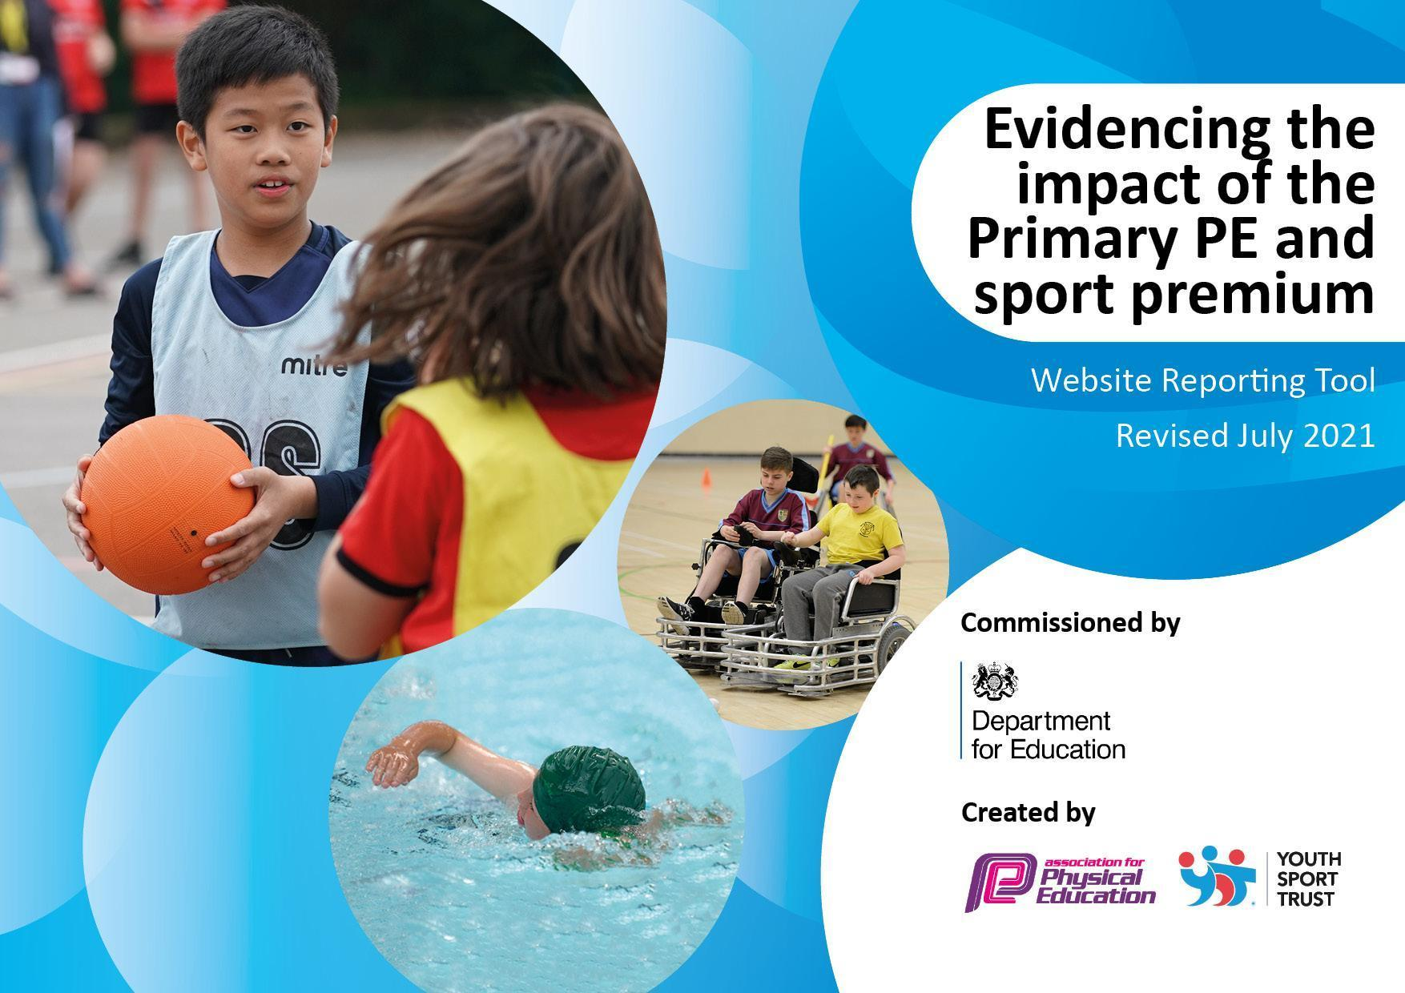
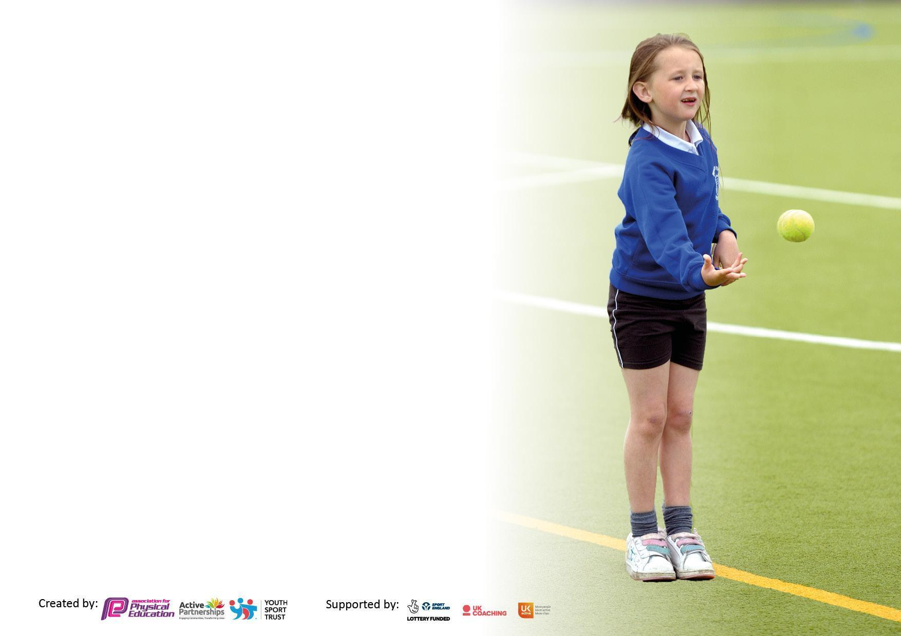

It is important that your grant is used effectively and based on school need. The Education Inspection Framework makes clear there will be a focus on ‘whether leaders and those responsible for governors all understand their respective roles and perform these in a way that enhances the effectiveness of the school’.

Under the Quality of Education Ofsted inspectors consider:
Intent - Curriculum design, coverage and appropriateness
Implementation - Curriculum delivery, Teaching (pedagogy) and Assessment
Impact - Attainment and progress

To assist schools with common transferable language this template has been developed to utilise the same three headings which should make your plans easily transferable between working documents.

Schools must use the funding to make additional and sustainable improvements to the quality of Physical Education, School Sport and Physical Activity (PESSPA) they offer. This means that you should use the Primary PE and sport premium to:

- Develop or add to the PESSPA activities that your school already offer
- Build capacity and capability within the school to ensure that improvements made now will benefit pupils joining the school in future years
- The Primary PE and sport premium should not be used to fund capital spend projects; the school’s budget should fund these.

Pleasevisitgov.ukfortherevisedDfEguidanceincludingthe5keyindicatorsacrosswhichschoolsshoulddemonstrate animprovement.Thisdocumentwillhelpyoutoreviewyourprovisionandtoreportyourspend.DfEencouragesschools to use this template as an effective way of meeting the reporting requirements of the Primary PE and sport premium.

We recommend you start by reflecting on the impact of current provision and reviewing the previous spend.

Schools are required to publish details of how they spend this funding, including any under-spend from 2019/2020, as well as on the impact it has on pupils’ PE and sport participation and attainment. All funding must be spent by 31st July 2022.

We recommend regularly updating the table and publishing it on your website throughout the year. This evidences your ongoing self-evaluation of how you are using the funding to secure maximum, sustainable impact. Final copy must be posted on your website by the end of the academic year and no later than the 31st July 2021. To see an example of how to complete the table please click HERE.


Created by: Supported by:

Details with regard to funding
Please complete the table below.

Total amount carried over from 2021/22
Total amount allocated for 2022/23 | £18,000
How much (if any) do you intend to carry over from this total fund into 2021/22? | £0
Total amount allocated for 2022/23
To be spent and reported on by 31st July 2023.

Swimming Data
Please report on your Swimming Data below.

Meeting national curriculum requirements for swimming and water safety.

N.B. Complete this section to your best ability. For example you might have practised safe self-rescue techniques on dry land which you can then transfer to the pool when school swimming restarts.
Due to exceptional circumstances priority should be given to ensuring that pupils can perform safe self rescue even if they do not fully meet the first two requirements of the NC programme of study
What percentage of your current Year 4 cohort swim competently, confidently and proficiently over a distance of at least 25 metres?  N.B. Even though your pupils may swim in another year please report on their attainment on leaving primary school at the end of the summer term 2022.  Please see note above | 50%
What percentage of your current Year 4 cohort use a range of strokes effectively [for example, front crawl, backstroke and breaststroke]?  Please see note above | 50%
What percentage of your current Year 6 cohort perform safe self-rescue in different water-based situations? | % NA
Schools can choose to use the Primary PE and sport premium to provide additional provision for swimming but this must be for activity over and above the national curriculum requirements. Have you used it in this way? | Yes/No

Action Plan and Budget Tracking
Capture your intended annual spend against the 5 key indicators. Clarify the success criteria and evidence of impact that you intend to measure to evaluate for pupils today and for the future.

Academic Year: 2022/23 | Total fund allocated: 18,000 | Date Updated:
Key indicator 1: The engagement of all pupils in regular physical activity – Chief Medical Officers guidelines recommend that primary school pupils undertake at least 30 minutes of physical activity a day in school |  |  |  | Percentage of total allocation:
 |  |  |  | %
Intent | Implementation |  | Impact
Your school focus should be clear what you want the pupils to know and be able to do and about  what they need to learn and to  consolidate through practice: | Make sure your actions to achieve are linked to your intentions: | Funding allocated: | Evidence of impact: what do pupils now know and what can they now do? What has changed? | Sustainability and suggested next steps:
- Children to take part in active learning via more physical lessons  - To encourage exercise and active play during break times and lunchtimes by implementing and using effectively new outdoor equipment  - Children to learn how to swim in order to stay safe when in water  (risk of falling into the nearby canal surrounding the local area)  - Children in EYFS to have daily access to a well-planned and broad range of outdoor activities in the outdoor EYS areas. | - As part of joining The Wyre Forest School Partnership, classes are to take part in live/virtual physical lessons on half termly basis  - New outdoor equipment purchased  - Extra sessions planned for current Y3 children in the Summer term 2023 to allow for more time to develop the basic swimming skills (nearly all of the current Y3 children have had no previous experience of swimming lessons)  - Plan for and design the outdoor EYFS areas to enable an active, purposeful learning  - Source playground company that can redesign and improve the EYFS area so that it becomes more suitable for an active, outdoor daily physical play | £2355  (part of Wye Forest School partnership contribution)  £……….. approx. | Those classes who took part have enjoyed the sessions. Children were actively involved; the physical exercise was linked to a theme/topic which made their learning even more meaningful  New playground markings were installed on the playground – Sept. 2022.  Children are engaged in new active games during break and lunchtimes, led by the Playleaders.  The ‘daily mile’ sign and its aim is being used more purposefully and accurately by classes in PE sessions as agreed with SLT team.  Classes continued to take part in active lessons throughout the year and thoroughly enjoyed it.  It has been a very successful initiative; Play Leaders have carried out their roles responsibly and have enjoyed their experience. A wide selection of play equipment has been used well and a number of lunchtime games have been implemented effectively. All children have enjoyed and benefited from the experience.  Out of 30 Y4 children, 15 were able to swim unaided 25m (Dec 2022)  SLT team agreed to use ESPPlay - Playground Equipment Specialists  to redesign the EYFS area. The work is scheduled for Autumn 1. | Children use the markings to play games during playtimes and lunch times. The different zones (linked to Regulation Stations) need to be embedded more and children need to be reminded of them.  Ind. classes have been using the ‘daily mile’ as part of their PE session; as a school, we need to agree on the future use of the marking.  To continue with the Playleaders; train and deploy new Playleaders from current Y3.  Top up/replenish outdoor play equipment.
Key indicator 2: The profile of PESSPA being raised across the school as a tool for whole school improvement |  |  |  | Percentage of total allocation:
 |  |  |  | %
Intent | Implementation |  | Impact
Your school focus should be clear what you want the pupils to know and be able to do and about  what they need to learn and to  consolidate through practice: | Make sure your actions to achieve are linked to your intentions: | Funding allocated: | Evidence of impact: what do pupils now know and what can they now do? What has changed? | Sustainability and suggested next steps:
- To develop the Early Years outdoor learning area in order to enhance and support the development of children’s core strength (gross and fine motor skills)  (this key skill development should translate into better preparation for writing in Rec/KS1 - Whole School Development Plan target)  - Targeted children to follow Smart Moves programme in order to improve their movement/coordination/balance  - To continue to use professional role models (coaches: dance, tennis, yoga, swimming) in school to deliver high quality PE lessons and inspire children to take up a wider range of sports  - To actively encourage pupils to take on leadership roles that support the delivery of sport and physical activity (Play leaders)  - To continue to train and deploy Play Leaders across the year groups to encourage and model physical activity to others  - To raise pupils’ awareness of how to keep themselves and others safe on the playground and in their play  - Teachers and children to have access to a wide range of relevant PE equipment in line with the new PE scheme | - JL and Early Years team to plan the outdoor area (a visit to Burlish Park School is planned for 15th Dec. in order to speak to their member of staff and seek their advice - the school has been recommended for their outstanding use of outdoor space).  - JL/NB to source outdoor playground companies that can redesign and refurbish the EYF area  - To purchase the SMART MOVES programme and deliver to targeted children across the school  - Plan for delivered/taught sessions on a weekly/termly basis; link the content of the lessons taught in Dance lessons to the topic in class (when possible)  - Teaches to observe, shadow and support deployed coaches in order to improve their PE teaching skills/techniques, knowledge and raise confidence level  - To liaise with the School Council and agree on the role of Play leaders and purpose of the Friendship Stop  - Use SSP initiative – bespoke support provided for teachers on termly basis – focus Dance/Gymnastics  - To liaise with SSP (Carolyn) to arrange for her to come and train Playleaders  - To audit and order new relevant PE equipment to be used next academic year in PE lessons | £2355  (part of the partnership contribution fee) | The session and the support offered on the day provided further guidance for EYFS teachers and it was reflected in their daily/weekly planning. As a result, meaningful and well-thought through outdoor play activities were planned and therefore children were engaged in and benefitted from a range of play activities.  JL sourced a number of Outdoor Playground Companies; she obtained 3 separate quotes. Unfortunately, due to the rising costs and very high prices, the decision was made not to pursue with the redevelopment of the EYFS’s area.  It was agreed that this programme will be sourced for next academic year.  Children have enjoyed well planned lessons and learnt new skills. Coaches’ expertise in their own areas ensured high quality coaching.  Yoga sessions provided mindfulness and mental well-being.  Tennis sessions improved eye-hand co-ordination as well as created a chance to try out a sport that many of the children might not have had a chance to try before.  Dance sessions provided a very high quality lessons, where children were able to learn dance moves linked to a topic taught in another curriculum area, such as English or Science.  Play Leaders were trained and took an active part in supporting and encouraging exercise through play during lunch times.  A number of ind. pieces of PE equipment were purchased throughout the year depending on the need (based on the new PE scheme/planning). As a result, a wide range of relevant equipment (linked to GetSet4PE scheme) was in use in PE sessions. Children were able to experiment and practice on and with a range of equipment. | Continue to plan for a meaningful outdoor daily physical play next term.  To continue working alongside professional coaches and gain more knowledge, confidence and expertise of the delivery of different units of PE.

Key indicator 3: Increased confidence, knowledge and skills of all staff in teaching PE and sport |  |  |  | Percentage of total allocation:
 |  |  |  | %
Intent | Implementation |  | Impact
Your school focus should be clear | Make sure your actions to | Funding | Evidence of impact: what do | Sustainability and suggested
what you want the pupils to know | achieve are linked to your | allocated: | pupils now know and what | next steps:
and be able to do and about | intentions: |  | can they now do? What has
what they need to learn and to |  |  | changed?
consolidate through practice:
- Children in the Early Years to have access to a wide range of purposefully planned outdoor learning activities to support their wholistic learning  - Children to have an opportunity to develop and work on enjoyable, progressive dance sequences  - Raise the profile of teaching Dance across school by upskilling members of staff  - Provide staff with professional development opportunities, appropriate training and resources to help them teach PE and sport more effectively and confidently (Use SSP bespoke initiative, focus on ind. Areas of need)  - Continue to hire qualified sports coaches to work alongside teachers to enhance or extend current opportunities offered to pupils | - Early Years staff to have ‘bespoke’ support on planning and preparation of outdoor learning activities from staff from Burlish Park Primary school  - Source a Dance Specialist to come and deliver dance sessions with different year groups to develop progression in sequences of dance in all year groups throughout the course of the year  - dance sessions to be linked to the term’s topics (teachers to liaise with the coach) to enhance children’s cross-curricular learning and make links when/where possible  - Plan for Dance sequences to be delivered at least once a year (one half term)  - PE coordinator to attend PE conferences on a regular basis  - Use SSP Bespoke initiative sessions to target staff in order to develop weak areas in PE knowledge and teaching  - Teachers should learn from coaches the necessary skills to be able to teach these new sports and physical activities effectively  - Teachers to use the new PE scheme Get Set 4 PE systematically and progressively | £2355  (part of Wye Forest School partnership contribution)  £1375 + VAT  (per annum) | Children in all year groups have benefitted from well planned and enjoyable dance sessions linked to the topic they have been learning in class (delivered by Cassie, dance teacher). They have developed a sequence of new movements and worked together on learning their new dance routines. They improved their overall confidence in solo and group performance.  Y4 class used their dance sessions to prepare ‘end of the year’ class dance performance.  Furthermore, the sessions improved teachers’ confidence on how to develop and deliver a dance sequence based on a topic taught in class.  Y3 and Y4 members of staff have benefitted from the regular PE skills development/lesson delivery support throughout the academic year (supported by Carolyn - Bespoke Support Wyre Forest Partnership). Staff commented how much they’ve enjoyed the support and how much more confident they have become at delivering PE lessons as a result of that initiative.  Sports coaches – very successful; children enjoy sessions and are introduced to a wide variety of sports; coaches are very professional and run well planned, enjoyable sessions (tennis and cricket).  Children have developed many new skills in each unit taught as well as developed a more competitive spirit after taking part in games.  Also, this initiative allowed to introduce many children to new sport disciplines (e.g. tennis) - a sport that they have never had a chance to experience before.  Teachers (after shadowing coaches and actively supporting them in lessons) have improved their confidence on how to deliver specific units in PE sessions more effectively. | To continue deploying sports coaches in lessons when relevant.
Key indicator 4: Broader experience of a range of sports and activities offered to all pupils |  |  |  | Percentage of total allocation:
Intent | Implementation |  | Impact
Your school focus should be clear | Make sure your actions to | Funding | Evidence of impact: what do | Sustainability and suggested
what you want the pupils to know | achieve are linked to your | allocated: | pupils now know and what | next steps:
and be able to do and about | intentions: |  | can they now do? What has
what they need to learn and to |  |  | changed?:
consolidate through practice:
- Children to have an opportunity to take part in after-school sports club in the Summer term  - Pupils to experience a broader and more quality coverage of different sport disciplines across the year groups throughout the academic year  - Children to enjoy taking part in sports competitions and develop an element of competitiveness  - More children to swim unaided by the end of Y4 and develop ‘love’ for swimming as one way of keeping healthy  - Children to be encouraged to take up swimming outside school as one way of keeping healthy  - Children to engage in fun activities focusing on their fine motor skills | - Arrange for an afterschool sports club to be available to KS2 children in the Summer term  - Extend the coverage of tennis in KS2 to allow for the development and consolidation of specific tennis skills  - All staff to follow the new LTP curriculum overview with a broad and balanced sports coverage.  - All staff to follow the new PE scheme GetSet4PE  - Partner with other schools and engage in termly sports festivals as part of Droitwich Cluster schools at Westacre Middle School  - Provide more time/number of swimming sessions for children in Y4 in order to increase the proportion of children who can swim 10m/25m | £2355  (part of Wyre Forest School partnership contribution)  £1188  (extra term of swimming) | Members of staff delivered after-school clubs as no success at finding sports agencies/coaches to deliver clubs this side of the school term.  A wider range of sport coaches has enabled classes throughout the whole school to access a much broader PE curriculum.  All sessions have been very well planned and delivered, addressing children’s needs.  Children enjoyed the sessions, learnt new skills and some pursued their new sport interests outside of school.  All staff members are happy with the LTP and follow it throughout the year ensuring a broad coverage of sports discipline  (evidence from Staff Questionnaires responses).  All staff are happy and confident using the new PE scheme (evidence from Staff Questionnaires responses).  No children able to swim unaided at the start of term | To deploy professional coaches to ensure quality after school clubs for September 2023.  JL has managed to secure two after school clubs to run in the Autumn term (Cricket) and Spring (Rugby).  To continue working alongside professional coaches.

Key indicator 5: Increased participation in competitive sport |  |  |  | Percentage of total allocation:
 |  |  |  | %
Intent | Implementation |  | Impact
Your school focus should be clear | Make sure your actions to | Funding | Evidence of impact: what do | Sustainability and suggested
what you want the pupils to know | achieve are linked to your | allocated: | pupils now know and what | next steps:
and be able to do and about | intentions: |  | can they now do? What has
what they need to learn and to |  |  | changed?:
consolidate through practice:
- To increase and actively encourage pupils’ participation in the School Games and take part in competitions and tournaments, both inter-house and with local schools in order to keep fit and healthy and represent their school in the local area  - Pupils to develop ‘the competitive spirit’ by taking part in PE Festivals with local primary schools (termly)  - Pupils to develop the values of determination, honesty, passion, respect and self-belief by participating in competitive games | - To encourage classes/year groups to compete against each other (Summer term – two Y4 classes/Y2 classes) – intra-school competitions  - Each year group to attend a ‘themed’ PE festival where children can practice their skills and take part in competitions with other schools in a fun and friendly way (organiser - Carolyn Goddard, held at Westacre Middle School) – inter-school competitions  - Engage with other schools in the pyramid cluster and take part in inter-school competitive games (organiser – Tracy Freer) | £2355  (part of Wyre Forest School partnership contribution) | Very successful in each year group; the festivals were well organised and enabled children to apply their skills at school in another, competitive context.  Children had an opportunity to challenge themselves and to have ‘a taste’ for what it means to take part in a competition as well as develop other skills such as team work, resilience, perseverance, ect. | A new person (Tracy Freer) in charge of School Games from Sept. 2022; sign up as a school.  To continue taking part in festivals (each year group if possible).

Signed off by
Head Teacher: | Rachel Roberts
Date:
Subject Leader: | Justyna Larke
Date: | 25.07.23
Governor:
Date:

