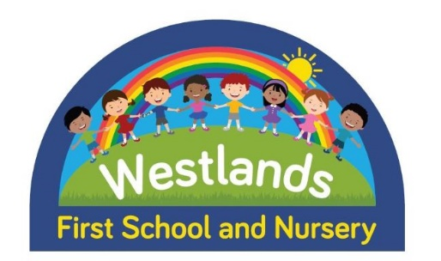

Spaces Available in our Teacher-Led Nursery
Do you, or does someone you know, have a child due to start Nursery in January? If so please get in touch so we can register a place for them!

Pop into the school office and we can get their name down and make a note of your preferred sessions. We are currently mornings only but if our numbers continue to rise we may be able to offer full days again

Why choose us?
Here are our Top 5 reasons why you should choose
Westlands School Nursery for your child!

- Teacher led with carefully planned opportunities to learn through play. With staff who have an up to date knowledge of learning and teaching in order to help your child make the best possible progress.
2) Joining us in Nursery helps the children develop a familiarity with staff and school routines such as PE and assembly, which then eases transition when they move on to Reception.
3) We receive weekly Speech and language support from a Specialist Speech and Language Therapist.
4) We offer a nurturing and happy environment where we strive to build strong relationships with parents and provide support if needed.
5) Our school ethos is that ‘Together we are a Rainbow of Possibilities’. It is our mission to help each child identify their unique talents, unlock their full potential in life and flourish into confident, happy, caring members of the community- Nursery is where this journey begins!
Get in touch! 01905 772740


